Push Notification setup in ionic

<https://documentation.onesignal.com/docs/ionic-sdk-setup>

https://documentation.onesignal.com/docs/using-postman

For Android using Onesignal

1.Registration and generate ,enable server key and sender id(google project no)

Copy and paste one signal and get app id of android

2.install one signal plugin

Install the Cordova and Ionic Native plugins:

$ ionic cordova plugin add onesignal-cordova-plugin  
$ npm install --save @ionic-native/onesignal

3.in home.ts

**import** { OneSignal } from '@ionic-native/onesignal';  
  
**constructor**(private oneSignal: OneSignal) { }  
  
...  
  
**this**.oneSignal.startInit('app_id_from_one_signal', 'google-project-no--senderid');  
  
**this**.oneSignal.inFocusDisplaying(**this**.oneSignal.OSInFocusDisplayOption.InAppAlert);  
  
**this**.oneSignal.handleNotificationReceived().subscribe(() => {  
 *// do something when notification is received*  
});  
  
**this**.oneSignal.handleNotificationOpened().subscribe(() => {  
 *// do something when a notification is opened*  
});  
  
**this**.oneSignal.endInit();

##################################################################

**Set for ios**

**Set Xcode lagacy build system form file->workspaceSetting**

sudo gem install cocoapods  
pod repo update

Again

ionic cordova plugin remove onesignal-cordova-plugin  
ionic cordova plugin add onesignal-cordova-plugin

5.0 Open <project-root>/platform/ios/YourAppName.xcworkspace

5.1 Select the root project and Under Capabilities Enable "Push Notifications".

5.2 Next Enable "Background Modes" and check "Remote notifications".

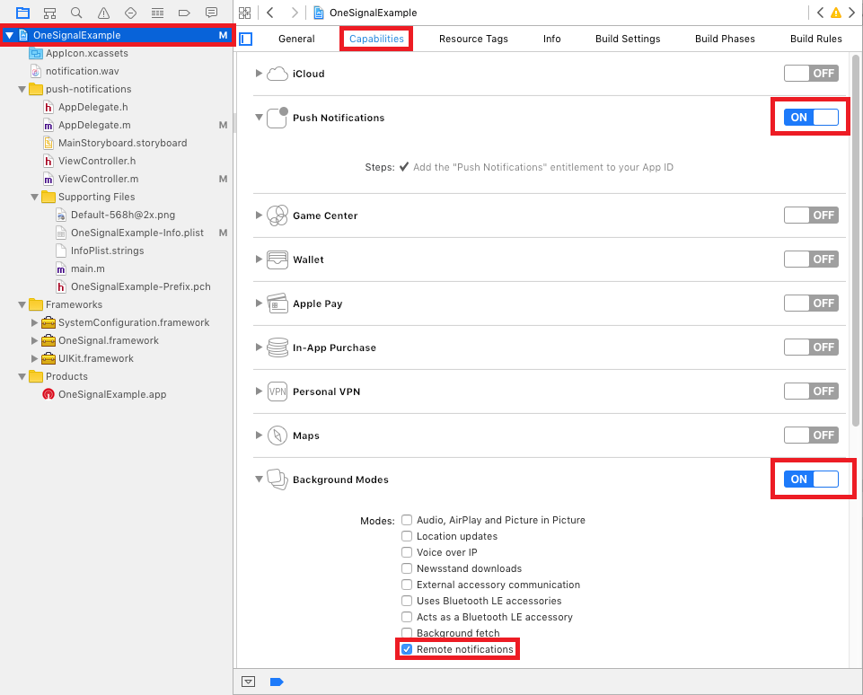

**\* start Optional**

Add Lib

5.7 Press the + and add SystemConfiguration.framework and UIKit.framework.

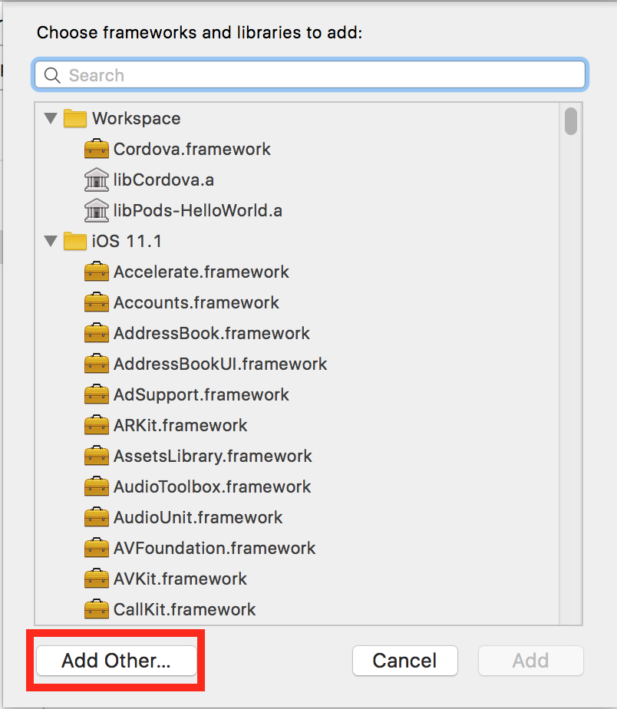

5.8 Press the + and click Add Other…

oneSingnal framework

… platforms/ios/Pods/OneSignal/iOS_SDK/OneSignalSDK/Framework/OneSignal.framework

5.9 Navigate to <Project-Root> > platforms > ios > Pods > OneSignalSDK > Framework >

Select OneSignal.framework and press Open

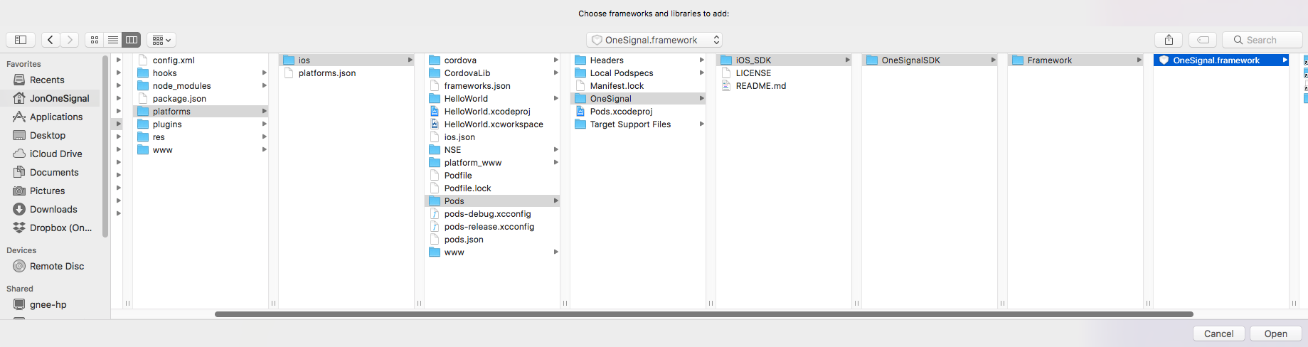

And done

5.10 You should now see all 3 frameworks

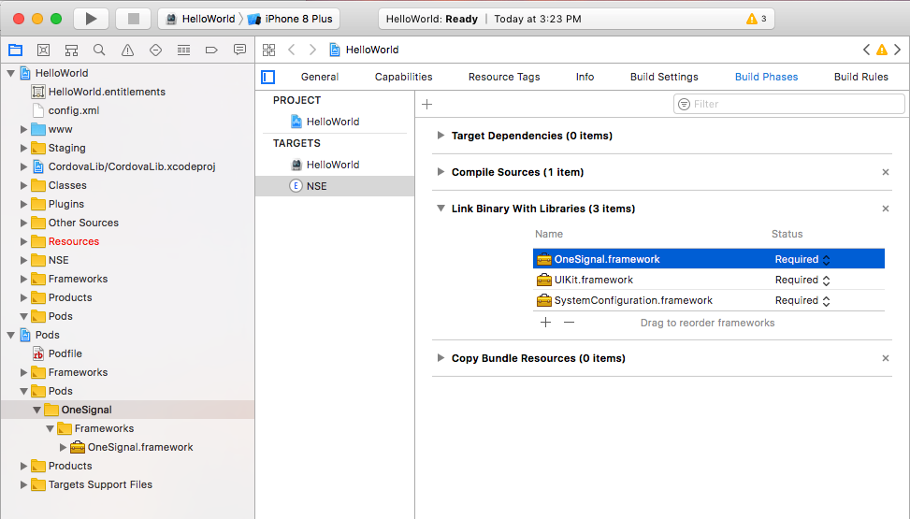

**\* End Optional**

Send Mesg from PostMan

<https://documentation.onesignal.com/docs/using-postman>

Or form

Http

function loadDoc() {

const method = "POST" const headers = {

"Content-type": "application/json"; "Authorization": "Basic xxxxxxxxxxxxxxxxxx"; } const body = JSON.stringify({ "app_id" : "xxxxxxxxxxxxxxxxxxxxxxxxxx", "contents": {"en": "Hello World!"} , "included_segments" : ["All"] }

)

return fetch("https://onesignal.com/api/v1/notification", {method, headers, body}) .then(handleAsText) .then(responseText => demo.textContent = responseText); }

**********************************complete-------------------------